Abstract— Increasing area overhead is a major design concern in low-power subthreshold SRAM designs, due to stability considerations. Since power performance can only improve at the expense of large area and delay penalties, this project evaluates the trade-off between area and power-delay product for some representative subthreshold SRAM designs, including 6T, 8T, and 10T cell configurations. Analytical models for stability in subthreshold SRAM in deep submicron technology are used to determine optimum transistor sizing for a given desired stability and supply voltage. Models for delay, power and EOP are also given. Therefore the tradeoff between power, delay, area for different designs can be investigated.
Area-performance tradeoffs in sub-threshold SRAM designs
EE241 Final Report
George Cramer (cramerg@eecs) and Ping-Chen Huang (pchuang@eecs)

Motivation
As electronics continue to be integrated into portable consumer devices, the demand grows not only for increased functionality, but also for long battery life and small physical size. This implies a need to balance ultra-low power with area-efficient design. Examples include wristwatches and hearing aids. An obvious way to minimize SRAM energy per operation is to decrease V_{DD}. This decreases active power, (~CV_{DD}²), as well as leakage power. If V_{DD} is decreased too sharply, however, increased delay time causes this leakage power to be integrated over a longer time interval, thus increasing the power-delay product (PDP). It has been shown that a minimum PDP corresponds to a supply located in the sub-threshold region. [4]
Implementing SRAM in subthreshold involves an explicit tradeoff between stability and area. Typical 6T SRAM achieves desired read / write margins by relying on ratioed current strengths set by transistor lengths/widths. But high sensitivity to V_{T} process variations, as well as degraded I_{on}/I_{off} ratios, renders these length/width-based ratios wholly unreliable for sub-V_{T} SRAM. In order to increase read/write stability, extra peripheral circuitry and/or additions to the 6T memory cell design can be utilized, at the cost of increased area. This motivated us to investigate the area-performance trade-off for subthreshold SRAM designs.

II. PROBLEM STATEMENT
In order to optimize power, delay and area in SRAM design, modeling of the memories is needed to characterize the behavior of the SRAM and help making design decisions before running SPICE simulations. Over the last decade, there have been many proposed models [5], [8] and tools [6], [7] developed to predict the SRAM performance. However, these models and tools are all based on traditional 6T SRAM design operated in superthreshold regime. Hence they didn’t consider the stability issue, which is the major metric that trades-off with the area in subthreshold SRAM design. Therefore, in this paper stability is modeled and taken into account in subthreshold SRAM performance trade-offs.
This paper compares the performance of the nominal 6T cell to the approaches taken by two representative sub-V_{T} designs. Our goal is to determine the most area-efficient method of maintaining sub-V_{T} SRAM read/write stability for applications requiring very low energy per operation.

SUB-V_{T} SRAM DESIGNS
In this paper, performance of two specific subthreshold SRAM designs [2], [4] are compared to the traditional 6T design. The design in [4] uses an 8T memory cell which only marginally adds to the typical SRAM cell area. The extra two transistors act as a buffer which protects the stored data during a memory read. Typically in 6T SRAM, at the onset of a read, the “0” memory state is connected to a precharged bitline, which raises the node’s voltage and reduces stability margins. The included buffer isolates this node from the bitline, thus allowing the read margin to equal the hold margin, which is typically much higher. Unfortunately, only a single word-line transistor, M8, blocks charge from leaking off RBL. High bitline leakage limits the number of rows that can connect to a single bitline, if the desired read current from a single row is to dominate the combined leakage from all other rows. The solution involves tying the feet of all unaccessed M7 buffers to V_{DD,} driven through a buffer. This introduces small area and power overheads. In particular, the power overhead is small if each word is located on a single row, since only one foot must be discharged to read all the cells in a word. Since the foot of the row being read must source I_{READ} from all cells in the row, the pull-down strength of this buffer must be quite high. A charge pump is used to boost the buffer’s input voltage to 2*V_{DD} in order to provide such high current strength while allowing the buffer itself to be of minimum size.
Additional area overhead arises from the need to ensure write stability. The PMOS pull-up transistors are connected to a secondary supply, VV_{DD}, which is lowered during a write in order to reduce the drive fight and ensure that a “0” can be successfully written. This technique requires that any cells connected to a given VV_{DD} be written at the same time, since a lower VV_{DD} drastically reduces hold margins. This causes a significant area overhead, since sense-amps and other column circuitry can no longer be shared, as would be expected with an interleaved column setup.
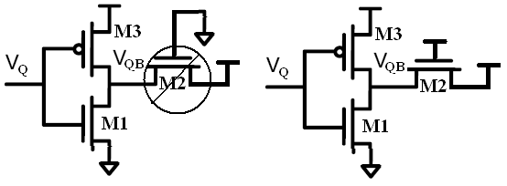
(a) (b)
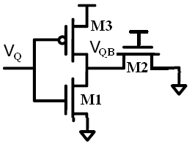
(c)

Fig.2. (a) Hold Stress, (b) Read Stress, (c) Write Stress
The design discussed in [2] uses a 10T memory cell. As with the 8T cell, the extra transistors are used as a buffer to maintain higher stability during read operations. The extra two transistors, M9 and M10, greatly reduce leakage current, both from V_{DD} and RBL. If node QB = “1”, the high PMOS leakage (relative to NMOS) keeps QBB ≈ “1”, which essentially eliminates bitline leakage. If QB = “0”, QBB is held fully at 1 through the PMOS, once again yielding zero bitline leakage. In fact, the leakage is so low that a successful read can be distinguished even with 256 cells connected to a single bitline. This significantly reduces peripheral area, justifying the 10T design. Similar to [4], [2] uses a lower PMOS V_{DD} to enable a negative write margin. In this case, VV_{DD} is left floating during a read, so that the ground-tied bitline gradually pulls it down, weakening the pull-up PMOS until the write is successful.

Reference | [4] | [2]
Memory Size | 256 kb | 256 kb
Area | 2.117 mm² | 2.117mm²
Tech Node | 65 nm | 65 nm
Total Power | 2.2 μW | 3.28 μW
Frequency | 25 khz | 475 kHz
Supply | 350 mV | 400 mV
Min Operating Supply | 350 mV | 380 mV

Table I. Performance summary of SRAM designs [2], [4].

Proposed Comparison/Solution
There are four main performance metrics for any SRAM design: stability, delay, power, and area. Each can be expressed in terms of sizing and Vdd. We assume a given constant stability for the three designs as the basis for comparison. As the Vdd scales down, the corresponding sizing for each design at a particular Vdd can be calculated. Once the sizing is determined at a particular Vdd, the power and delay can then be calculated or simulated. For subthreshold SRAM in particular, the ultimate goal is minimum overall power consumption while the delay can be tolerated in applications of interested. For this reason, our comparison does not seek to reduce delay specifically. Hence, the power-delay product or energy per operation (EOP) will be the primary figure of merit in our analysis. The comparison proposed here thus will determine the area efficiency of a given design as a function of the desired EOP.

A. Modeling Stability
If stability is assumed to be constant for all designs, then the SRAM cell transistor sizes must be determined appropriately, assuming a given supply voltage. This sizing can be determined through simulation, although this procedure is rather tedious and yields little intuition into what is really going on. Our approach was to express stability as a function of sizing and supply voltage, based off analytical expressions, and then utilize these expressions directly to determine transistor sizing in later simulations.
This paper models the hold, read, and write margins based on traditional Butterfly plots.

a. Hold Margin
If V_{Q} is low, V_{QB} is high and V_{DS}≈0, V_{GS}<0 for M2. If V_{Q} is high, V_{GS}=0 for both M2 and M3, but I_{PMOS}>I_{NMOS} in the sub-V_{T} operation. Thus, we may assume I_{M2}=0 when calculating hold margin. Setting I_{M1}=I_{M3},
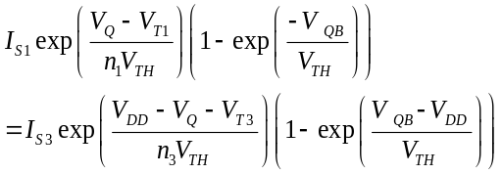
As shown in [10], solving for V_{Q} yields:
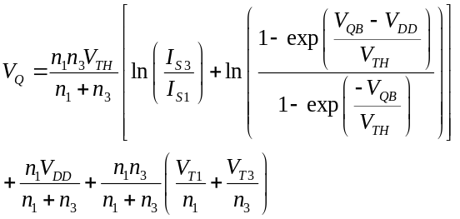
Inverting this equation and then solving for SNM_{hold} is computationally intractable. However, for regions of interest, using the provided 45nm PTM BSIM model it can be modeled as:
SNM_{hold}(V)=-0.0347+0.5*V_{DD}.

b. Read Margin
If V_{Q} is low, M2 has a low V_{DS}, so I_{M2}<<I_{M3}, yielding the same equation as before. If V_{Q} is high, M3 is turned off and I_{M2}>>I_{M3}. Setting I_{M1}=I_{M2},
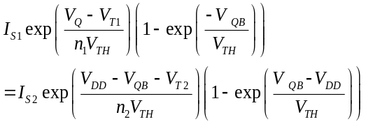
Solving,
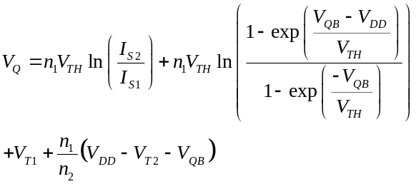
Since the analytical solution for SNM does not exist [10], but least-square fitting for the implemented BSIM model yields very closely models:
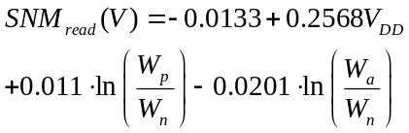
c. Write Margin
If V_{Q} is low, M1 is off and M2 and M3 are on. If V_{Q} is high, M3 is off and V_{QB}≈0. Therefore, solve for V_{Q} by setting I_{M2}=I_{M3}. Unlike for the hold and read margin cases, using the sub-V_{T} approximation for I_{M2} and I_{M3} does not yield an accurate solution of V_{Q}. This is because the exponential behavior of I_{D}(V_{GS}) is accurate only for V_{GS}<200mV,as shown in Fig. 3. This error, when applied to the drive fight between I_{M2} and I_{M3} at V_{Q}=0, yields a significantly different result for V_{QB}.
Finding an accurate value of V_{QB} depends on accurately modeling current in the moderate-V_{T} region, which is very difficult. With no other option, an expression for SNM_{write} was developed by manually fitting simulation results:
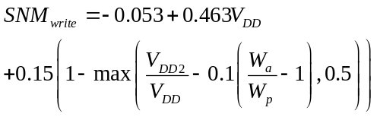
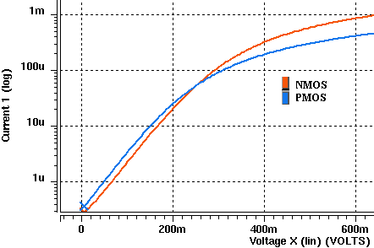

Fig.3. I_{D} as a function of V_{GS} for both NMOS and PMOS
where V_{DD2} is the voltage seen at the source of M3. Intuitively, the equation states that either lowering V_{DD2} or raising W_{a}/W_{p} will decrease the relative strength of M3, making a write easier to complete. However, this only works to a point, since SNM_{write} will no longer continues increasing once M2 completely overpowers M3.
The obstacle to meeting stability constraints in sub-V_{T} SRAM is V_{T} variation. This is due to the very high sensitivity of current to V_{T} in the subthreshold region. Thus, by no means will transistor size ratios alone ensure stability requirements will be met. However, V_{T} variations are not considered in this paper, so we will simply pick some high SNM (e.g. 150mV) which we assume will continue to meet specs for the desired 5σ-6σ of variation.

B. Modeling Delay and Power
For a 6T SRAM cell, the read delay Td can be approximated as
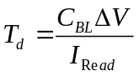
where ΔV is the input voltage difference required for the sense-amp and IRead is the read current.
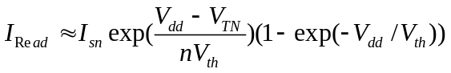
The total power Ptot is
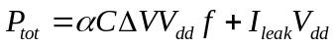
where α is the activity rate, f=1/2Td, and Ileak is the leakage current supplied from Vdd
Hence the EOP can be obtained
With CBL=20fF, ΔV=0.8Vdd, and activity rate α=1, and all minumin-sized devices, the analytical and simulated EOP of the traditional 6T is shown in Fig. 4. The reason why we cannot see a dip in this plot is because α=1, where leakage power is still low. As α decreases, the leakage power starts coming into play and causes EOP the local minimum.
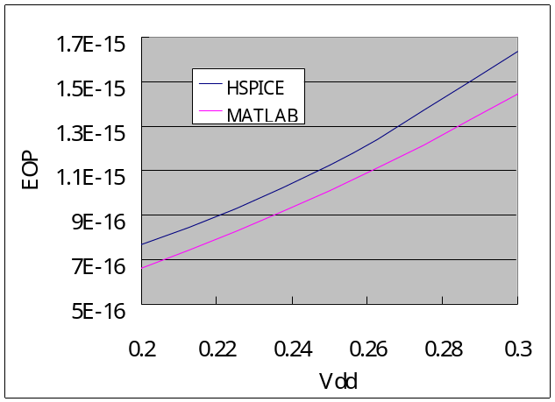

Fig.4. Analytical and simulated results of EOP versus Vdd for 6T SRAM cell
V. ANALYSIS
Now that expressions for stability, delay, and power have been developed, it is now possible to estimate the area versus EOP for each SRAM design. VV_{DD}/V_{DD} is assumed to be 0.8 for all cases. This is necessary to ensure a high SNM_{write} in subthreshold, where PMOS is stronger than NMOS. First, we set bounds on stability: minimum SNM_{read}=80mV and SNM_{write} = 150mV. Fig. 5 shows the simulated SNM_{read} for several combinations of sizings and V_{DD}, with the sizings picked using the SNM expressions developed in the previous section. SNM_{read} consistently matches the expected value, with the exception being for V_{DD}=0.3V, where w_{p}/w_{n} ≈ 9. (Few SRAM designs would realistically have such a high size ratio, due to the high cost in area, so this data point is irrelevant in practice.) SNM_{read} exceeds 80mV for V_{DD}=0.5V simply because the cell has minimum size and cannot be scaled down any further.
For both the 8T and the 10T cells, the read stability margin is not an issue. Therefore, sizing is subject only to the write margin constraint. The figure below simulates SNM_{write} as a function of V_{DD} and sizing. Sizing is picked by setting SNM_{write} = 150mV in the equation developed last section.
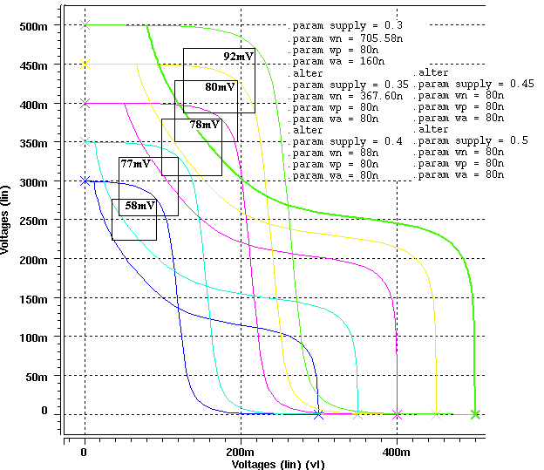
Fig.5. Simulated SNM_{read} for desired SNM_{read}=80mV cell, using the SNM model to determine sizing

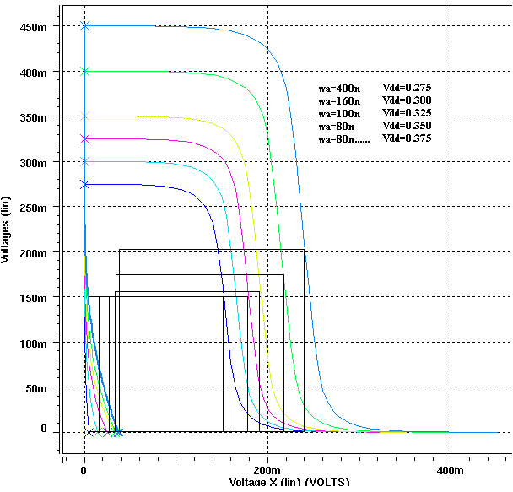
Fig. 7. Simulated SNM_{write} for desired SNM_{write} >= 150mV using simulation results to determine sizing

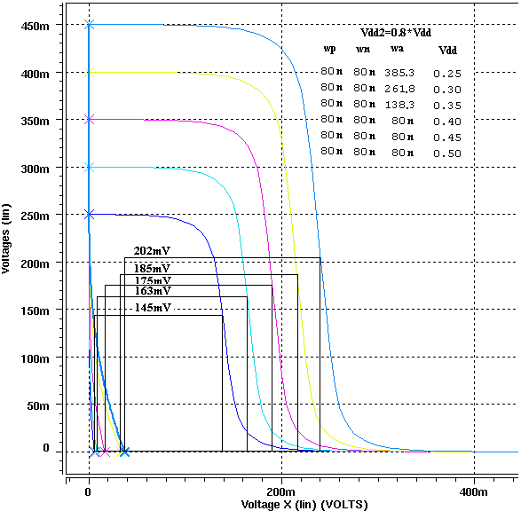
Fig.6. Simulated SNM_{write} for desired SNM_{write}=150mV using the SNM model to determine sizing

Once the sizing is determined at each Vdd, the power, delay, EOP, and area can be obtained. Fig. 8 shows the power, delay and EOP of the three designs. The 6T design has the smallest read delay since its path from the internal node storing the data to the read bitline has the smallest equivalent resistance of all three designs. In our simulation setup, with α=1, the dynamic power dominates, so the 6T one has the largest power. The EOP for the 8T is higher than that of 10T because the 8T design requires extra power to switch the buffer-foot inverter during each read. Fig. 9 shows the area versus EOP for three cases. For low EOP applications, the 6T design area must increase dramatically to meet both read and write stability requirements. Although the 10T design has more transistors, it is actually more area-efficient in extreme low EOP regime. However, for only moderately low EOP, stability requirements are met even with minimum sizing. In this case, the 8T design requires less area.

Conclusion
In this paper, models for stability, power, delay are used to investigated the area-EOP trade-off for three representative subthreshold SRAM designs. Power, delay, and EOP for each design are compared as Vdd scales down. The 10T design has the smallest EOP and is most area-efficient in low EOP region.
References
- Y. Kwon, D. Pavlidis, T. L. Brock, D. C. Streit, “A D-band monolithic fundamental oscillator using InP-based HEMT’s,” IEEE Trans. on Microwave Theory and Tech., vol. 41, no. 12, pp. 2336-2344, Dec. 1993.
- B. H. Calhoun and A. P. Chandrakasan, "A 256-kb 65-nm sub-threshold SRAM design for ultra-low-voltage operation," IEEE Journal of Solid-State Circuits, vol. 42, no. 3, Mar. 2007, pp. 680-688.
- J. Chen, L.T. Clark and T.-H. Chen, "An ultra-low-power memory with a subthreshold power supply voltage," IEEE Journal of Solid-State Circuits, vol. 41, no. 10, Oct. 2006, pp. 2344-2353.
- N. Verma and A. P. Chandrakasan, “A 256 kb 65 nm 8T Subthreshold SRAM Employing Sense-Amplifier Redundancy,” IEEE Journal of Solid-State Circuits, vol. 43, no. 1, Jan. 2008, pp. 141-149.
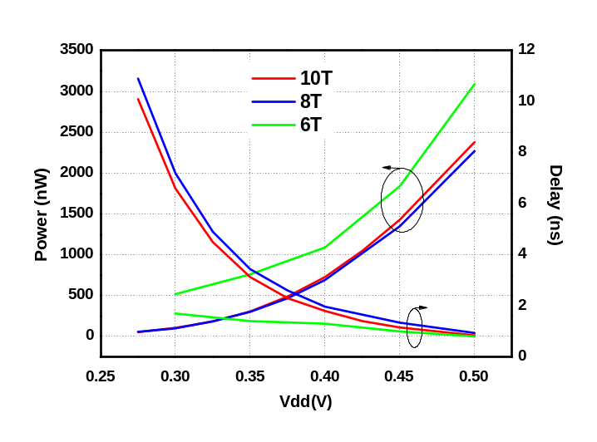
(a)
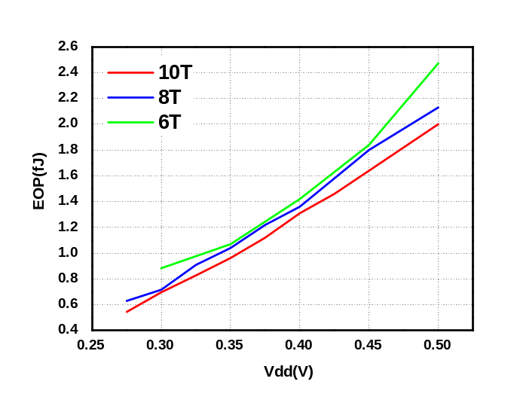
(b)
Fig. 8 (a) Power, delay, and (b) EOP versus Vdd for the three SRAM designs.
- B. Amrutur and M. Horowitz, “Speed and power scaling of SARM’s,” IEEE Journal of Solid-State Circuits, vol. 35, no. 2, Feb. 2000, pp. 175-185.
- P. Shivakumar and N. P. Jouppi, “CACTI 3.0: an integrated cache timing, power, and area model,” Aug. 2001.
- M. Mamidipaka and N. Dutt, “eCACTI: An enhanced power model for on-chip caches,” Tech. Rep. CECS TR-04-28, Sep. 2004.
- B. Agrawal, T. Sherwood, “Guiding architectural SRAM models,” International Conference on Computer Design, Oct. 2007, pp. 276-392.
- Do, M. Q., M. Drazdziulis, P. Larsson-Edefors, and L. Bengtsson “Leakage-Conscious Architecture-Level Power Estimation for Partitioned and Power-Gated SRAM Arrays.” Proceedings of the 8th International Symposium on Quality Electronic Design, pp. 185-191, Mar. 2007.
- B. H. Calhoun and A. P. Chandrakasan, “Static Noise Margin Variation for Sub-Threshold SRAM in 65-nm CMOS,” ," IEEE Journal of Solid-State Circuits, vol. 41, no. 7, Jul. 2007, pp. 1673-1679.
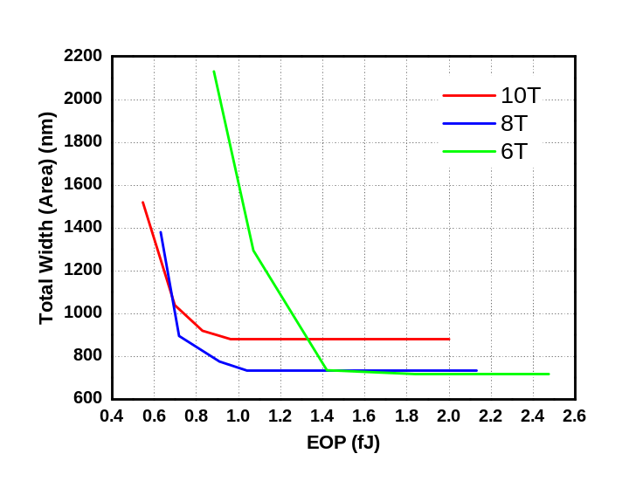
Fig. 9 Area versus EOP for the three SRAM designs.

 

